**Custom order function:**

*You can use your temporary account and this seller’s account to run the test :   
a.c: lvyliu

key: Enginetheme0215

Her service: <https://nt150.com/mjob_post/%e7%be%8e%e5%9c%8bmba-%e6%ad%90%e7%be%8e%e5%a4%a7%e5%ad%b8-application-essay-%e6%88%96-personal-statement-%e8%8b%b1%e6%96%87%e8%ab%96%e6%96%87%e4%bf%ae%e6%94%b9%e7%b7%a8%e8%bc%af/>

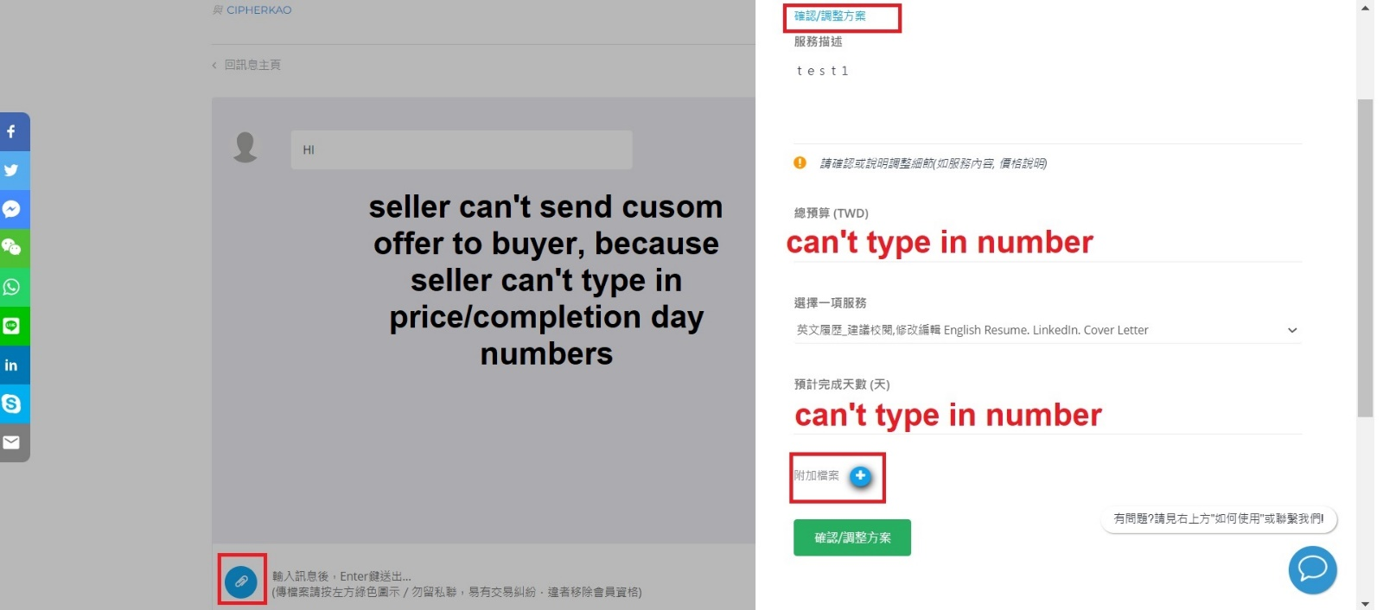

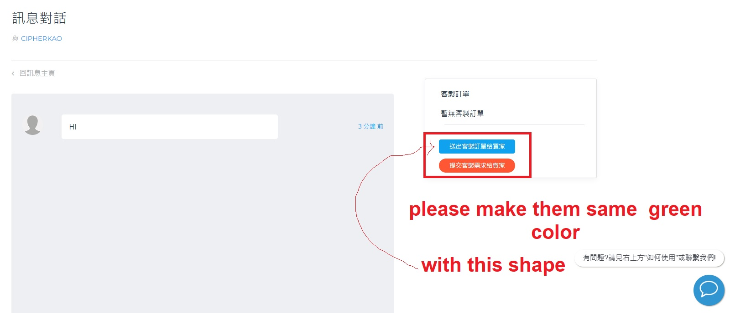

I know you make the color difference for clarity, but then the site doesn’t look neat with many theme colors on the site.

After changing button with same shape/color, adding “” on text will meet the reminder goal

Current Blue button text : 送出客製訂單[給買家]

Current Orange button text : 提交客製需求[給賣家]

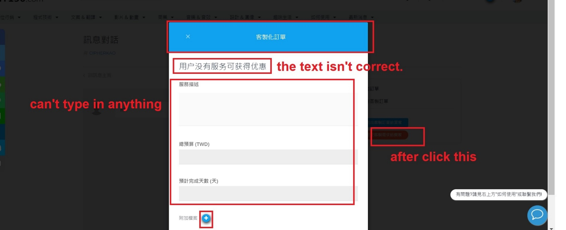

Please use the text I sent you yesterday You have no service to send custom offer “您尚無服務可客製”

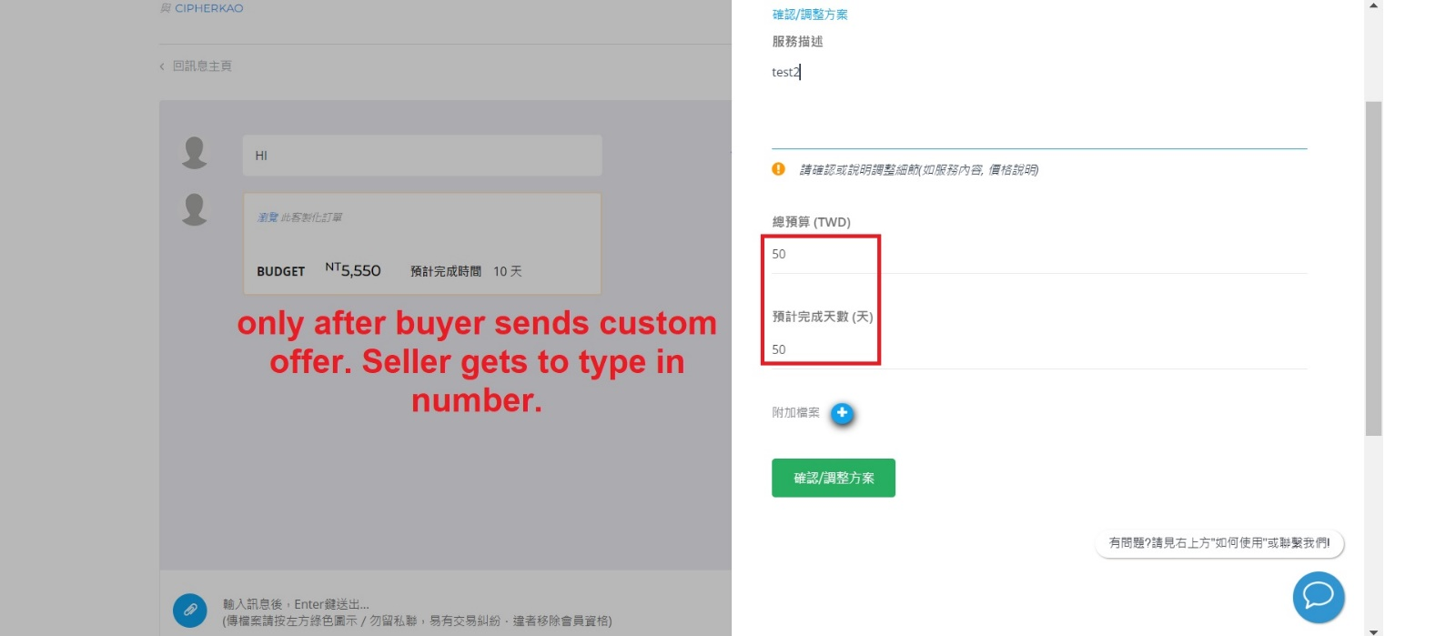

**Paypal, ecpy position**

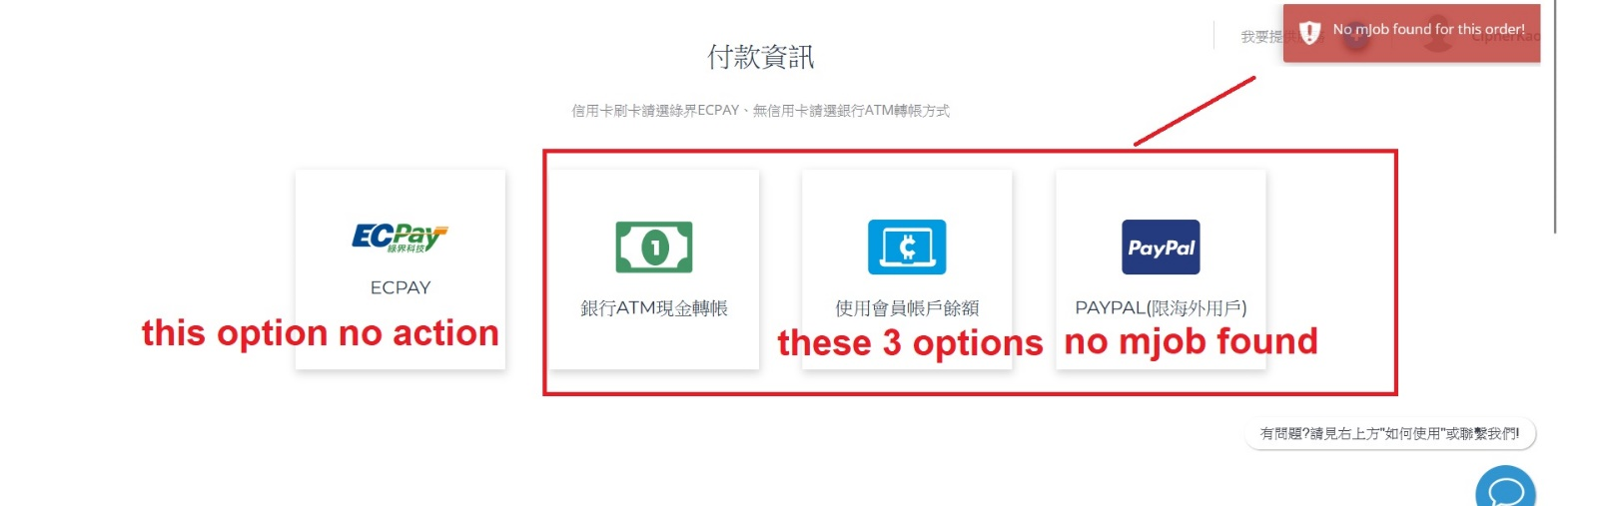

Order isn’t passing. ECpay isn’t activated after such change.

**Child theme color issue.**

Some are green, some are blue. Just printscreen some part for your reference. It needs to be green everywhere like the live site.

